FURTHER MATHEMATICS (Unit 3)

APPLICATION TASK(SAC) 2018

CORE: Data Analysis
REACTION TIMES

The SAC is designed to run in 3 sittings (3 parts)

Student Name: ____________________________________________________________

Total marks /80

INTRODUCTION:
In senior science students have been testing their reaction time with their dominant and non-dominant hands. They use a computer program and must click on an object when a pattern appears firstly with their dominant hand and then their non-dominant hand. Their reaction time in seconds is recorded.

The Head of Science Mrs. Beaker is interested in a few different research questions.
- Is there a difference between sex and reaction time?
- Is there a difference between sex and dominant and non-dominant hand reaction time?
- Is it possible to predict a person’s non-dominant hand reaction time from their dominant hand reaction time?
These questions and others will be investigated in this assessment
Using the data given to you in the excel spreadsheet, answer the following questions.

Data from ABS website: http://www.cas.abs.gov.au/cgi-local/cassampler.pl

Part 1:
- Represent the reaction times for female dominant and non-dominant hand reaction times in an appropriate graphical display. Calculate appropriate statistics to 2 decimal places.
Label all axes.
(8 marks)
- Explain why you chose the graphical representation in Question 1.
(2 marks)
- Compare the two distributions in terms of shape, centre and spread. Give appropriate statistics to justify your responses
(3 marks)
- Comment on how the non-dominant reaction times for females compare to the dominant reaction times for females for the data.
(2 marks)
- Represent the reaction times for male dominant and non-dominant hand reaction times in an appropriate graphical display. Calculate appropriate statistics to 2 decimal places.
Label all axes necessary.
(8 marks)
- Compare the two distributions in terms of shape, centre and spread. Give appropriate statistics to justify your responses
(3 marks)
- Using the information from the graph in Q5, explain why the reaction time for males is associated with the hand used (dominant or non-dominant). Quote the values of appropriate statistics in your response.
(2 marks).

Part 2
- Construct a histogram showing the dominant reaction times. Select a suitable width and justify your choice.
(4 marks)
- Describe the shape of the histogram.
(1 mark)
- Which measure of centre gives the best indication of the dominant hand reaction times? Explain your answer.
(2 marks)

- Calculate the % of people with a reaction time below 30%
(1 marks)
Below is a histogram of the non-dominant hand reaction times
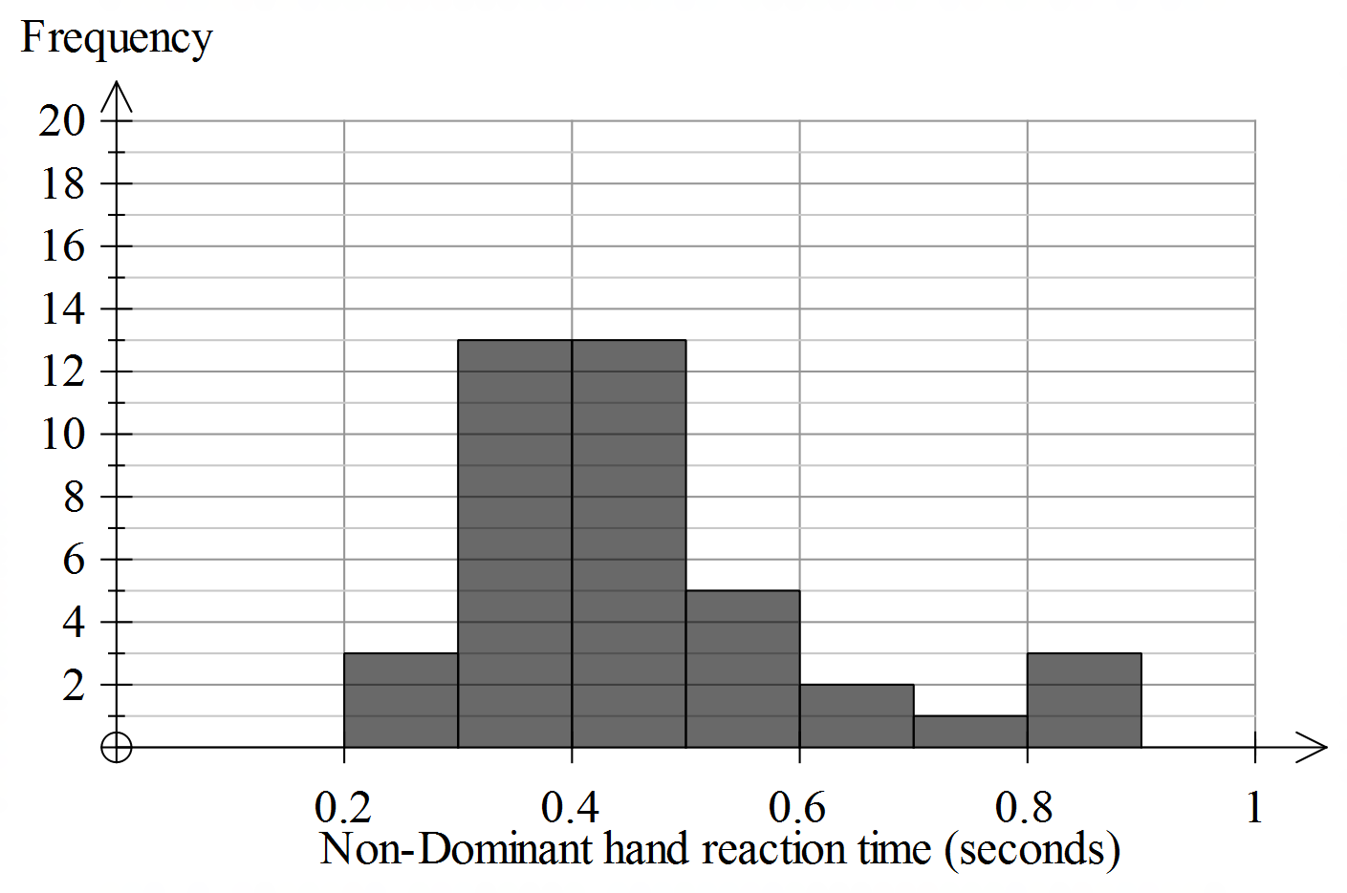
- Describe the shape of the histogram in terms of shape, centre and spread.
(3 marks)
- Mrs Beaker wants to apply the 68-95-99.7% rule to the non-dominant hand reaction times as shown in the histogram in Q7. Explain why the 68-95-99.7% should not be used with this data.
(2 marks)
The science classes are interested in investigating whether the reaction time of a person’s dominant hand is related with the person’s reaction time of their non-dominant hand.
To investigate this, they create a scatterplot showing the relationship between reaction times for the dominant and non-dominant hands
- Create a scatterplot and calculate the linear regression equation, correlation coefficient and correlation of determination. Interpret these statistics with respect to the context.
(8 marks)
8. What does the y intercept and slop of the equation tell us about the data?
(2 marks)
9. Draw a residual plot, based on your regression line and comment on what the residual plot shows.
Based on your analysis of residuals and the scatterplot, apply three transformations. Write down these transformation, new equations and correlation coefficients. Use this information to determine the most suitable model for making predictions.

(11 marks)

10. Use the most suitable equation to predict the non-dominant hand reaction time for someone with a dominant hand reaction time of 0.32 seconds and 0.81 seconds. Also use the same equation to make a prediction for dominant hand reaction time using a non-dominant reaction time of 0.45 seconds. Discuss the reliability of the predictions found.

(8 marks)

Part 3
The senior science students undertake a 4-week program to try and improve their reaction times.
Below is a table showing how many minutes students spend on the computer completing the program from Monday to Friday.

 | Monday | Tuesday | Wednesday | Thursday | Friday
Week 1 | 6.5 | 3.5 | 10 | 6.5 | 4
Week 2 | 5.5 | 2 | 12.5 | 7 | 3.5
Week 3 | 6 | 3 | 15 | 8.5 | 5.5
Week 4 | 7 | 4.5 | 13.5 | 9 | 6

- Draw a time series plot of the minutes spent using the program over the four weeks and describe the time series plot.
(4 marks)
- Use an appropriate smoothing method, smooth the data, plot the smoothed data on the same time series plot using in Q1 and comment on the effectiveness of the smoothed data in revealing any underlying trends.
(6 marks)
END OF TASK

